**CAD CAM in action**

Vahn Kessler

Mrs. Moose

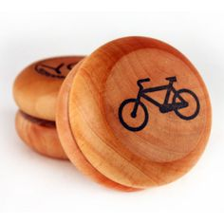19 February 2019

CIM

***Put a picture of your finished yo-yo hear and then DELETE this text box and the picture!!***

**Purpose:**

The purpose of this project is to refine CAD CAM strategies and skills to create a final project.

**.NC Code**

**`**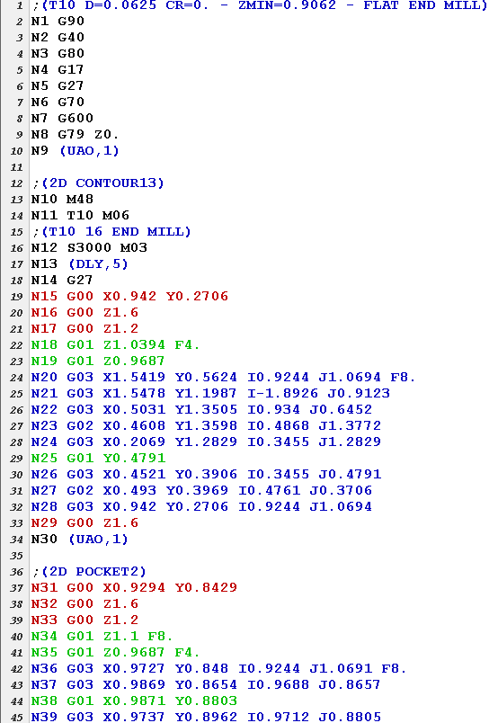

**Design Proposal**

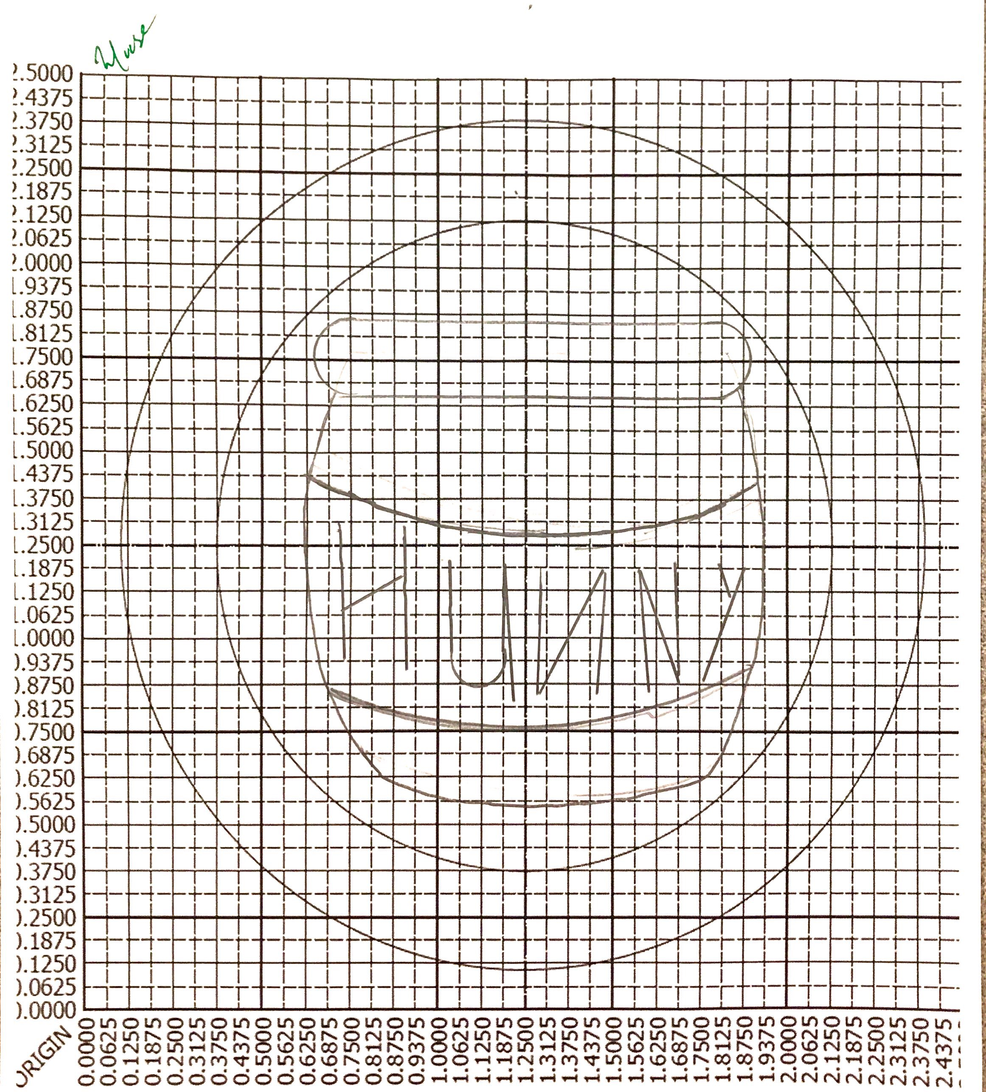

**Design Results and Lessons Learned**

**Inventor Model Browser**

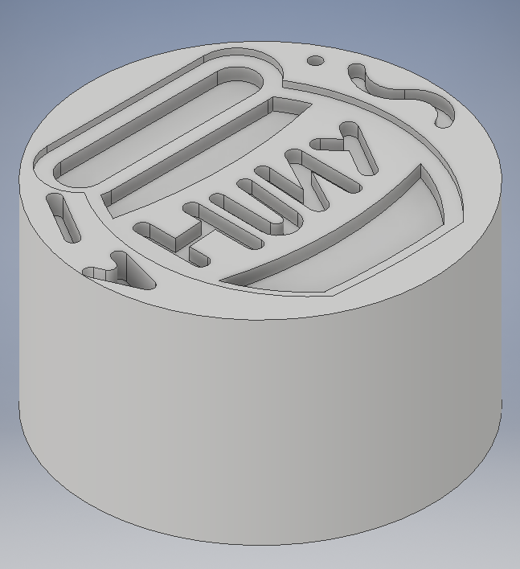 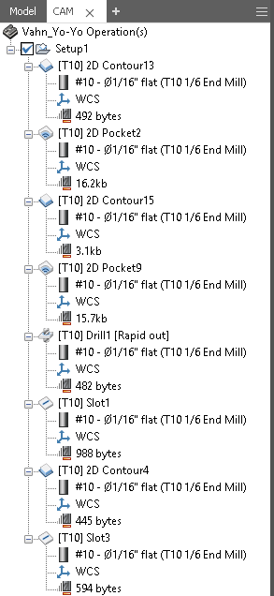

**Simulation Physical Result**

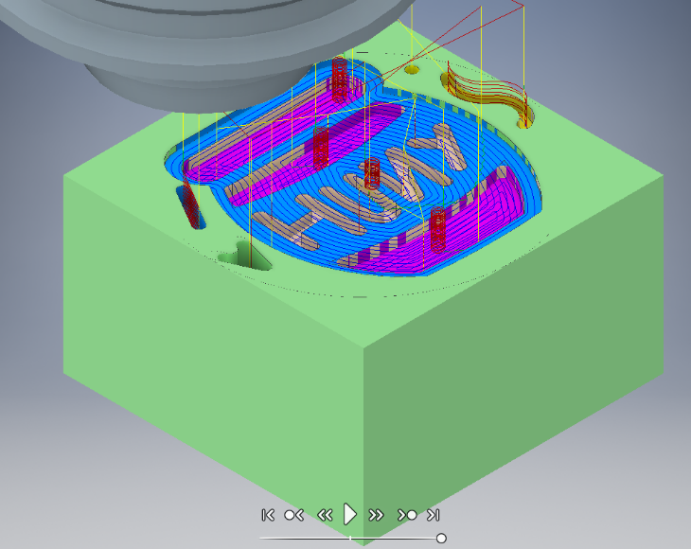

**Reflection:**

1. Did you like this activity? Was it exciting to cut your design on a yo-yo? Why or why not?
2. Understandably this is your first exposure to it and there is much more to learn, but do you feel as though you have a solid fundamental understanding of using CAD CAM strategies? Why or why not?

|  |
| --- |
| **CAD CAM in Action Rubric CIM** |

Read through this before submitting your work! Make sure that everything is organized and formatted appropriately including but not limited to fonts, titles, etc.

|  |  |
| --- | --- |
| 1. Student completed a design proposal of an appropriate design that is up to students’ ability level. | _______/5 |
| 1. Student uses neat and accurate lines, considers principles and elements of design when designing the final design and layout, and includes a signature from instructor. | _______/5 |
| 1. Student correctly sets CAM strategies to fully create design in yo-yo. | _______/10 |
| 1. Student includes all four required pictures of the development of their yo-yo. | _______/4 |
| 1. Student completes reflection, answering questions given, in a thoughtful way. | _______/4 |
| 1. Student uses project template, formats it appropriately, and includes all necessary documentation (fully and accurately completed) in their written report. | _______/4 |
| **TOTAL** | **_______/32** |